

**TO DEVELOP A PROJECT ON**

**ONLINE COMPLAINT MANAGEMENT SYSTEM**

**(MERN stack by MongoDB)**

A PROJECT REPORT

**Submitted by**

**VINOTH S - 110521104056**

**YAMINI E - 110521104057**

**YOGESH BALAJI K - 110521104058**

**DARWIN KUMAR R - 110521104301**

**In partial fulfilment for the award of the degree**

*Of*

BACHELOR OF ENGINEERING

IN

DEPARTMENT OF COMPUTER SCIENCE AND ENGINEERING

GOJAN SCHOOL OF BUSINESS AND TECHNOLOGY

ANNA UNIVERSITY, CHENNAI-600 052

Abstract

Online Complaint Management System provides an online way of solving the problems faced by the public by saving time and eradicate corruption.

The objective of the complaints management system is to make complaints easier to coordinate, monitor, track and resolve, and to provide company with an effective tool to identify and target problem areas, monitor complaints handling performance and make business improvements.

Online Complaint Management is a management technique for assessing, analyzing and responding to customer complaints. Complaints management software is used to record resolve and respond to customer complaints, requests as well as facilitate any other feedback.

The main purpose of this project is to help the public in knowing their place details and getting their problems solved in online without going to the officer regularly until the problem is solved. By this system the public can save his time and eradicate corruption in government offices.In the proposed system the citizen need not go to the government office for getting his problem solved.

He can get his problem solved by posting his problem in this proposed system and he can suggest a possible solution to the problems posted on the system. He can even get the information of the funds and other details of his place in detail through this system. Keywords: online , complaint , management , respond , customer .

1. INTRODUCTION

In India we don’t have any direct communication between the government and public in an efficient way for solving the problems for getting a problem solved in our place we have to bribe the officials and get them solved in 2 months which can be solved actually in 1 month of time. In order to overcome this problem previously National Informatics Centre has launched a site named Prajavani through which public can post the petitions or complaints in the site and get them solved in a specified time and can also know the status of the complaint or petition he has lodged at any time.

NIC has launched this site with the goal of Right TO Information Act (RTI Act) i.e. providing the complete information of a place to the user at any time.

it failed in providing the complete information to the public and is providing only the complaint lodging facility to the public.

Ther are four modules for this system are Guest • Dlps operator Government officer Super user In order to make the goal of NIC come true we are going to develop a system which will be able to provide the complete information to the public at any point of time regarding the problems they are facing currently and what is the impact of it and then how effectively the funds are utilized for the development purpose can be known by public which also includes the online discussion forums and feedback forms which will help them to communicate well with the government.

It concludes by publishing a newsletter and a magazine to the registered users of the system which gives the complete details of the district for every month.

Cathy Costantino and Cristina S Merchant, and Karl A. Slaikeu and Ralph H. Hasson extensively explored issues of designing conflict management systems.

The concept of an integrated conflict management system was conceived and developed by Mary Rowe, in numerous articles in the 1980s and 1990s.

She saw the need to offer options for complainants and therefore a linked system of choices within an organizational system. The idea of a systems approach has endured well.

In recent years however, there has been discussion as to whether conflict should be "managed" by the organization—or whether the goal is to understand, deal with and learn from conflict. There is also concern about practical and theoretical issues in "integrating" a system, with some observers preferring the idea of "coordinating" a conflict system.

# WhatsApp Image 2024-11-07 at 13.20.00_c2177342

However 2012 research by David Lipsky et al., suggests that an increasing number of corporations see themselves as having "integrated conflict management systems," or "ICMS." 1.2 Analysis of Problem 1.2.1 Purpose of the System Online Complaint Management System provides an online way of solving the problem faced by the public by saving time and eradicate corruption and the ability of providing many of the reports on the system and add to facilitate the process of submitting a complaint.

1.2.2 Existing System In the existing system the citizens must go to the government office for any kind of help. For complaining about a problem there is a system called Prajavani in which the users can post their problems but cannot get the details of the problems and some other services.

# WhatsApp Image 2024-11-07 at 13.19.58_20ff7d88

This system doesn’t have much popularity and is not user friendly. 1.2.2.1Problem in Existing System The following are the drawbacks present in the existing system. •

No registration facility is provided and can post the problems directly. •

Have to install suitable fonts and software available in the website for using the system. •

Can’t get the information regarding funds allotted to the problem and other basic information. •

Fake problems can be entered and there is no possibility to verify before solving the problem. •

A citizen can’t give a suggestion for solving the problem in a better way.

1.2.3 Proposed System The Complaint Management System is one of the most significant and resource intensive project in which proposed system the citizen need not go to the government office for getting his problem solved. He can get his problem solved by posting his problem in this proposed system thus is to encourage and assist public sector and he can suggest a possible solution to the problems posted on the system. He can even get the information of the funds and other details of his place in detail through this system.

# WhatsApp Image 2024-11-07 at 13.19.59_31114f03

Our proposed system provides solution to existing system by extending its facilities as follows: •

Registration is provided so that officer can solve the problems easily Complete information regarding the place is displayed. •

Can suggest a solution for solving the problems in a better way,Can comment on the government’s decisions.

METHODOLOGY AND PROPOSED WORK

**1 Users of the System**

* Guest ▪
* Dlps Operators ▪
* Government officers ▪
* Super user

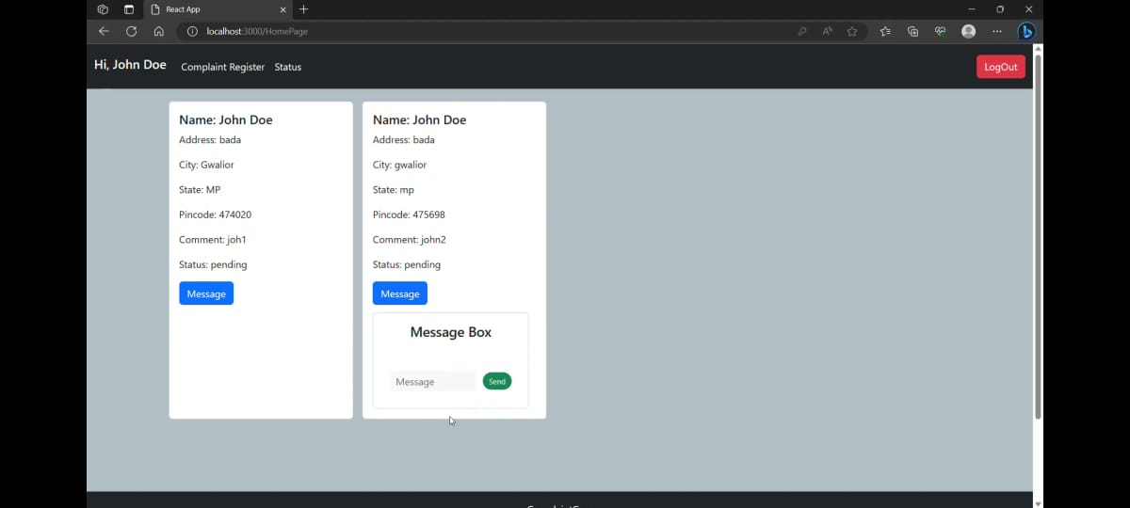

Guest can login to the system and know the complete information and can post the problem.

Operator:Dlps Operator is the end user who has a valid login id and password.

The DLPS operators will get the complete information about the place including the problems from the survey officials. 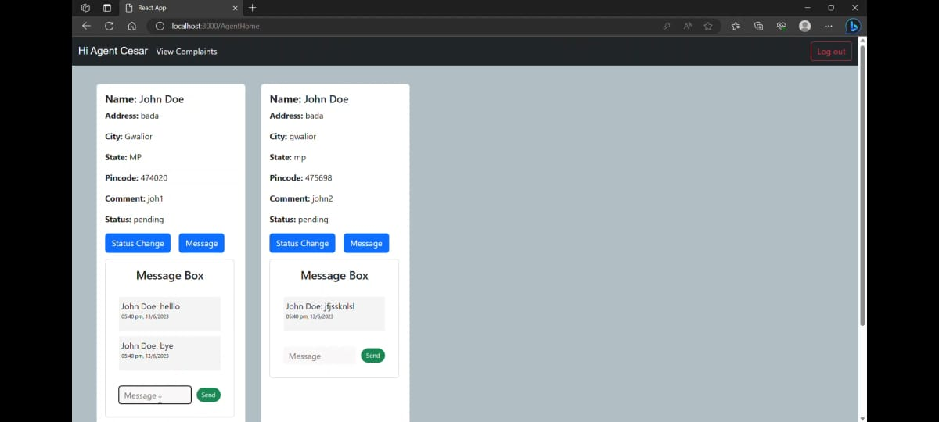

These operators are spread throughout the district and will process the information to the corresponding authorities and will update the system with current information Government Officer is the end user who has a valid login id and password.

Government Officerwill monitor a place without going to their and get the information and takes the corresponding action. Then discusses it with higher officials and releases funds. 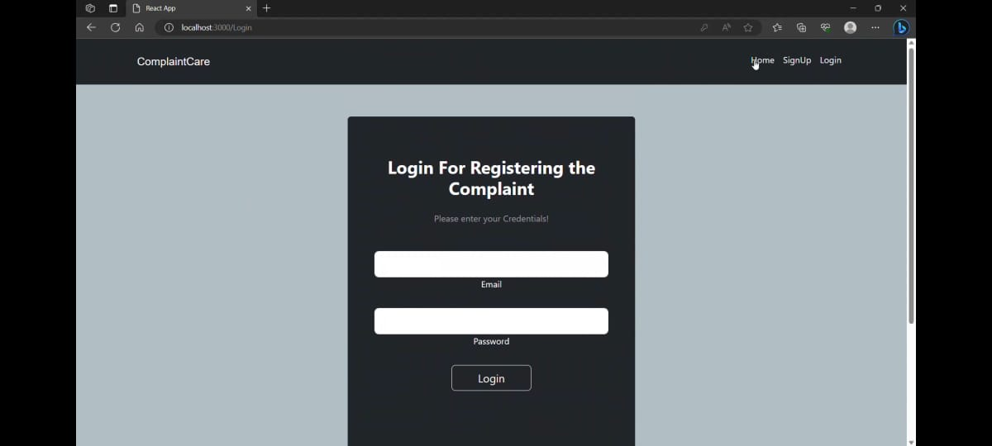

Super User:Super User is the end user who has a valid login id and password.

# WhatsApp Image 2024-11-07 at 13.20.00_2b1fa1a3

To perform Technical administrative work like to Create Logins, Add andModify Officer information and to solve the technical problems etc. Each District hasone Super User.

# WhatsApp Image 2024-11-07 at 13.31.34_00efd134

CONCLUSION

Application software has been computed successfiully and was also tested successfully by taking “test cases”. It is user friendly , and has required option, which can be utilized by the user to perform the desired operations.

Application software meets the information requirements specified to a great extent.

The system has been designed keeping in view the present and future requirements in mind and made very flexible.

The goals that are achieved by the software are Instant access, improved productivity, Optimum utilization of resources, Efficient management of records, Simplifications of the operations, Less processing time and getting required information, User friendly, Portable and flexible for further enhancement.

ACKNOWLEDGEMENT It gives us a great pleasure to submit the paper topic titled “Android based transportation system”.

We wish to take this opportunity to express our heartiest gratitude with pleasure to J.D.I.E.T., Yavatmal, which gave us an opportunity in fulfilling our most cherished desire of reaching our goals. We are indebted to a proactive guide Prof.

1. K. Popat, Assistance Professor of department because without his valuable guidance this work would not be a success. His constructive, useful, timely suggestions and encouragement in every step immensely helped us to carry out our project work.

His invaluable presence was a great boost for us in achieving up a goal.

We are very much indebted to Head of Department Prof. J. H. Saturwar and Principal Dr. A. W. Kolhatkar, for providing all the facilities needed for successful completion of this project and providing necessary assistance while preparing for this Project work. We are very much thankful to all Professors and staff members of Computer Science and Engineering Department. We also express my deep gratitude to our parents and all our friendswho directly and indirectly helped us to prepare this project. REFERENCES [1] Osman Nasr AndEnayatAlkhider, Online Complaint Management System. Vol.2 issue 6 June 2015. [2] H. Kim, P. Howland, And H. Park, “Dimension Reduction In Textclassification With Support Vector Machines,” J. Machine Learning Research, Vol. 6, Pp. 37-53, 2005. [3] E.F. Combarro, E. Montan˜ E´S, I. Dı´Az, J. Ranilla, And R. Mones , “Introducing A Family Of Linear Measures For Feature Selection In Text Categorization,” Ieee Trans. Knowledge And Data Eng., Vol. 17, No. 9, Pp. 1223-1232, Sept. 2005 [4] F. Sebastiani, “Machine Learning In Automated Text Categorization,” Acm Computing Surveys, Vol. 34, No. 1, Pp. 1-47, 2002